Why the project?

During Covid 19, came the pandemic of Free-time. So to somehow get through this very tough time, I had the brilliant never thought before idea of watching some movies. But from the myriads of movies available online, selecting a good movie is no easy feat.
Which is why I thought about coding this algorithm.

What is Cosine Similarity?
I have used cosine similarity for the code. It is a method to measure the difference between two non zero vectors of an inner product space. A bit of maths there!

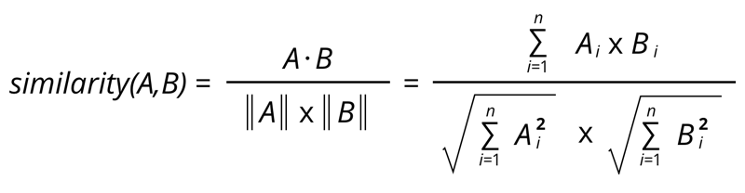
So just basic math.

But beyond the complicated looking formula, the concept is simple. If we had a matrix of ratings of two movies from two users and plotted the values as vectors in space, the cosine of the angle between the two vectors would give us the similarity between the two.

Now some might wonder why this cosine then? Simple. Think about the two users as yourself only. In that case, your rating vectors would overlap which means the theta angle between the two vectors would be zero.

And for those not well acquainted with maths, cos 0 = 1. So in this manner we scale the similarity between zero and one.

Now whats with personalized?

Cosine similarity in code uses tokenized words from the dataset. This would give me the movie smost similar to the one I requested.

But but….

Personally my taste in movies is a bit opprobrious, which is why I prefer my movies to atleast lie in the critically well received spectrum.

Let me explain with an example.

I really loved the movie Speed (1994), an edge of the seat thriller starring the breathtaking Keanu Reeves.

Now using only Cosine similarity, my first recommendation would be Speed 2.

But “Speed 2: Cruise Control”, the only edge of the seat experience any audience will feel is when they get off their seats and leave.

So I changed it!

Taking IMDB ratings as that parameter, I have mathematically modeled the two so as to get a nice balance point where the similarity and critical acclaim create a new point system.
This allows me to be recommended only good movies while keeping the theme and premise of the movie similar to the one I asked for.

